Linux Set-Up Notes
We usually export MLIB under /home2/micfs/[userid] using svn command and make.
The Disk mounted under the /home2/micfs/ have enough capacity.
- Make directory named /home2/micfs/[userid]
Please make directory named /home2/micfs/[userid]
Now /home2/micfs/ is here.
[hirayake@tkirsclt36 ~]$ ls /home2/micfs/
fuhiroka fuktakay hirayake jenkins jenkins-test-data logs service_logs tsuchryo vuduchuy
Under /home2/micfs/[userid] you can freely make directories and so on.
2. Checkout trunk_comon
And please export trunk_common using svn command.
Ex).
[hirayake@tkirsclt36 20180724]$ pwd
/home2/micfs/hirayake/work/20180724
[hirayake@tkirsclt36 20180724]$ svn checkout http://tkcvsapd1/repos/M-Library/trunk/global/trunk_common
The all components in trunk_common would be exported.
I have copied my .bash_profile to /tmp/20180724_hirayake. Please refer to this file for environment setting.
- Copy Environment Set-Up & Use Bash Shell
Copy Hirayama-san’s environment setup to your home directory:
cp /tmp/20180724_hirayake/.bash_profile ~/hirayama.bash_profile
By default my shell is csh ( not bash ). I can see this by typing:
echo $0
So run all subsequent commands using bash, I start bash and load in all of Hirayama-san’s config:
bash
source hirayama.bash_profile
I then continued to follow the instructions below,
cd Under /home2/micfs/[userid]/work/20180724/trunk_common/src
make

- Please make
Please change directory to trunk_common/src and type make.
To parallelize and use 8 cores type: make –j 8 which means make 8 jobs at a time
Ex).
[hirayake@tkirsclt36 20180724]$ cd trunk_common/src/
[hirayake@tkirsclt36 src]$ make
The Make would begin.
Then the binary file named single_client will be made under trunk_common/src/bin with each library files made under trunk_common/src/lib.
single_client is the base exe file for IR server in Tokyo.

Note: Compiler Versions & Linux Server Upgrade
tkirsclt36 is the old server with RedHat6.4 and intel compiler 14.0.1.
Now we have ordered the new server with RedHat7.3 and intel compiler 18.2.
I hope we would be able to use the new server around this November.
PuTTy Settings
- Enter Server IP Address and Select SSH
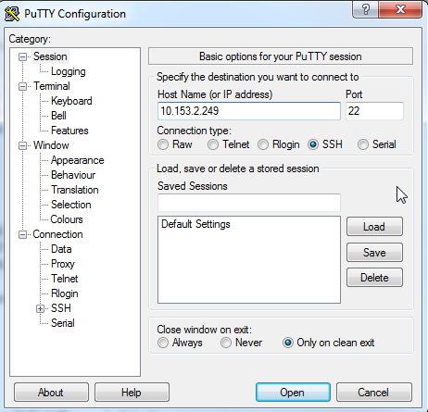
- Add Your Login ID
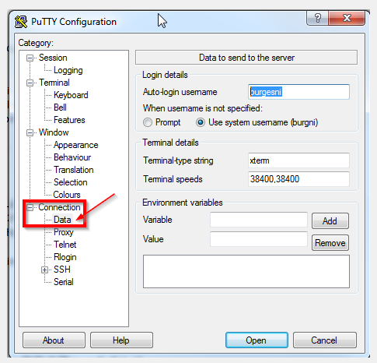
- Set the Command Interpreter to use bash (default is often cshell)
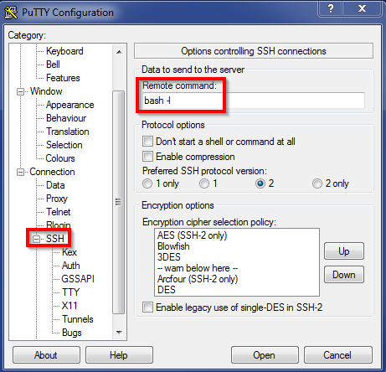
- Save the Connection Settings for Future then Select Open
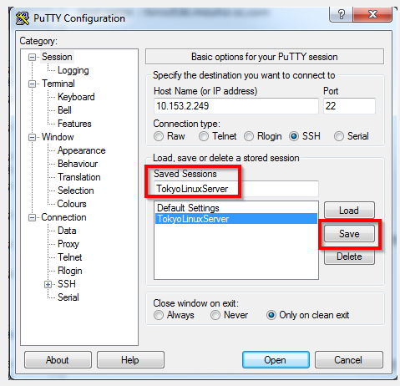

- Select Yes to Trust and Connect
